DIS-US-Navajo-Randall Beyale-

Navajo sculptor and artist Randall Beyale from Crownpoint, New Mexico is a member of the Red Running into the Water Clan. Randall’s inspiration is from his heritage and he is involved with the Navajo Tribal Ceremonies. His work has won many awards from Native American shows. Randall’s work is in collections throughout the country. "Inspired by the ways of his Dine' heritage as an Artist, he continues to look for the soul in the stone and upon finding it he only brings out what is already there ..........." Randall's inspiration is from his heritage and he is very involved with the Navajo Tribal Ceremonies. His work has won many awards from Native American Shows, and his work is in collections throughout the country.

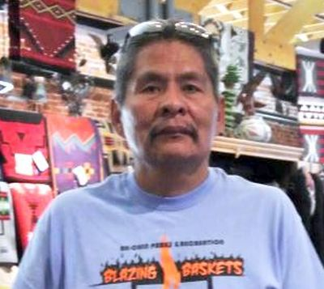

A Partial List of Awards and Mentions:

2003 - Gallup Inter-Tribal Ceremonial  
Honorable Mention

1998 – Fountain Hills, Arizona Art Festival

1st Place, “Whispers in the Wind”

1997 – Heard Museum   Phoenix, Arizona

Honorable Mention, “Grandma’s Approval”

1997 – Collector’s Choice    Scottsdale, Arizona

Best in Class, “Grandma’s Approval”

1996 – Heard Museum   Phoenix, Arizona

Best of Division, “Awakening” (Bronze)

1995 - Southwest Mountain Art Festival  
Honorable Mention, Governor's Award, People's Choice

1995 - Heard Museum   Phoenix, Arizona  
Honorable Mention, “Unconditional Love”

1994 - Gallup Inter-Tribal   Gallup, New Mexico  
2nd & 3rd Place, “Solitude”

1993 - Gallup Inter-Tribal   Gallup, New Mexico  
1st Place

1992 - Gallup Inter-Tribal   Gallup, New Mexico  
3rd Place, “Uncommon Valor”

1992 - Totah Festival    Farmington, New Mexico

1st Place, “Beyond Tradition”

|  |  |
| --- | --- |
|  | **Product ID:** sclpt-10a    **Category:** Sculptures **Sculpture** **Description:** Authentic Navajo Alabaster Sculpture. Indian with Buffalo Headress. Won Third Prize at the Gallup Inter-Tribal Ceremonial 2006. 12 3/8" x 9 1/2". Artist: Alvin Marshall. ~CLICK ON PICTURE FOR DETAILS~ ***SOLD 11/13/08*** **Price:**  $1,800.00 |